**Problem**:

In recent years, city hotel and resort hotel have seen high cancellation rates which causes fewer revenues and less than ideal room use.

My task is to offer business advice to address this problem.

**Assumption:**

1. No unusual occurrences between 2015 and 2017 will have a substantial impact on the data used.
2. The information is correct and can be used to analyze hotel’s possible plans in an efficient manner.
3. There are no unanticipated negatives to the hotel employing any advised technique.
4. The hotels are not using any of the suggested solution.
5. The biggest factor affecting business is the booking cancellations.
6. Cancellation results in vacant room for the booked length of time,
7. Clients make hotel reservation the same year they make cancellation

**Research Question:**

1. What are the variables that affect the hotel reservation cancellation?
2. How can we make hotel reservation cancellation better?
3. How will hotels be assisted in making pricing and promotional decisions?

**Hypothesis:**

1. More cancellation occurs when the prices are high.
2. When there is a longer waiting list, customer lend to cancel more frequently.
3. Majority of client make reservation through offline travel agents.

Observations:

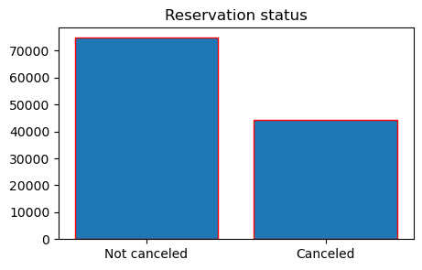

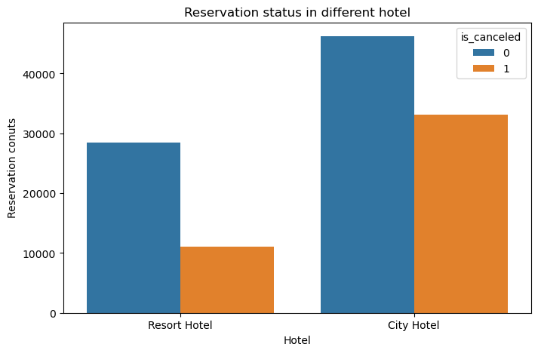

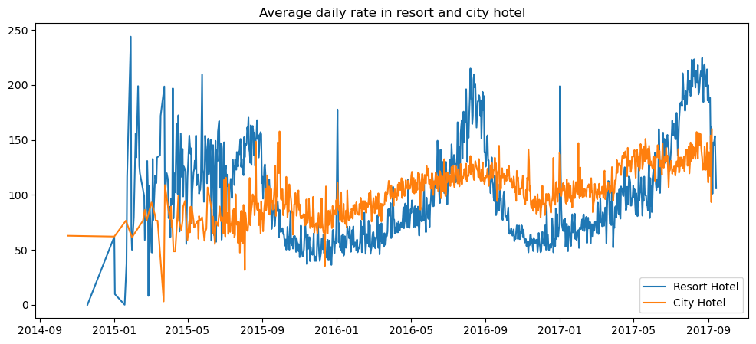

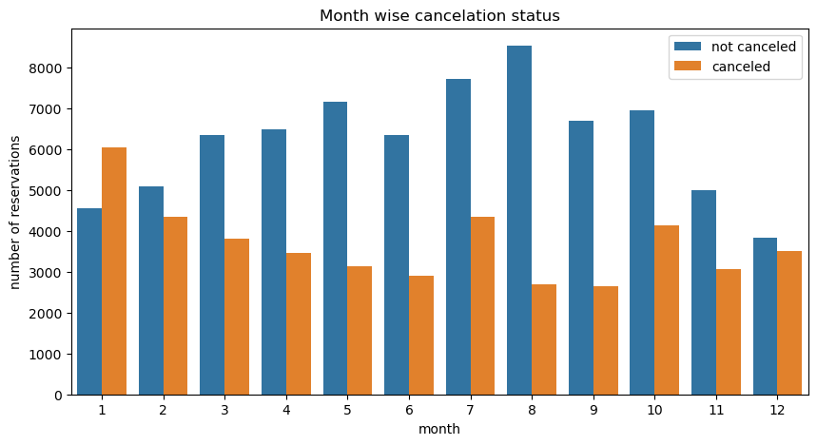

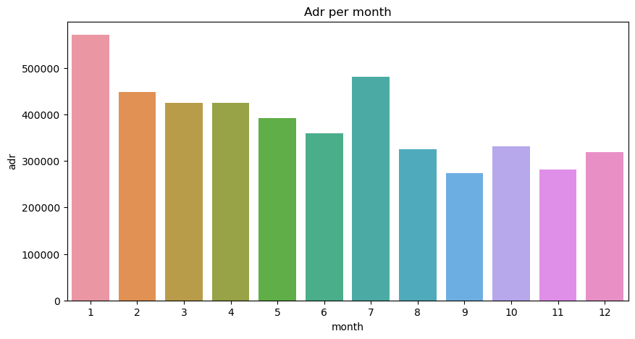

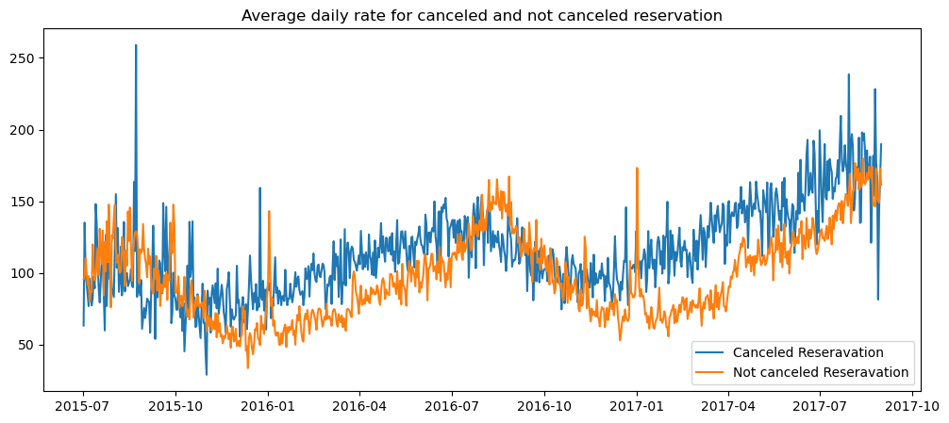

Suggestions:

1. In the month of January, hotels can start campaigns and marketing with a reasonable amount to increase their revenue as the cancellation is the highest in this month.
2. They can also increase the quality of their hotels and their services mainly in Portugal to reduce the cancellation rate.
3. Cancellation rates rise s the price does. To prevent cancellation, hotel could work on their pricing strategies. Try to lower the rates for specific hotels based on location.
4. As the ration of cancellation and not cancellation of the resort hotel is higher than the city hotel, they should provide a discount of the room process on weekends and holidays.